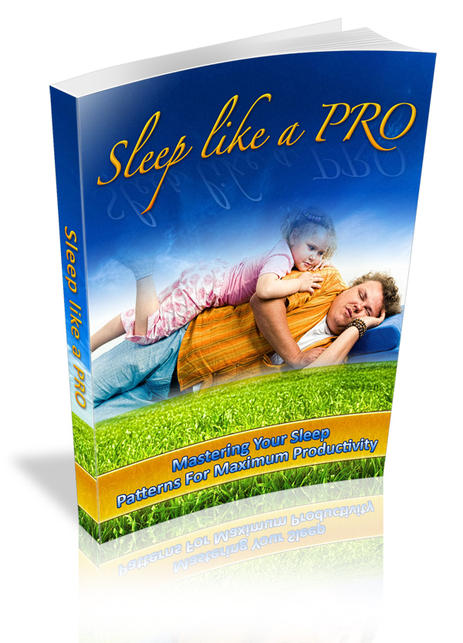

Terms and Conditions

LEGAL NOTICE

The Publisher has strived to be as accurate and complete as possible in the creation of this report, notwithstanding the fact that he does not warrant or represent at any time that the contents within are accurate due to the rapidly changing nature of the Internet.

While all attempts have been made to verify information provided in this publication, the Publisher assumes no responsibility for errors, omissions, or contrary interpretation of the subject matter herein. Any perceived slights of specific persons, peoples, or organizations are unintentional.

In practical advice books, like anything else in life, there are no guarantees of income made. Readers are cautioned to reply on their own judgment about their individual circumstances to act accordingly.

This book is not intended for use as a source of legal, business, accounting or financial advice. All readers are advised to seek services of competent professionals in legal, business, accounting and finance fields.

You are encouraged to print this book for easy reading.

Table Of Contents

Foreword

Chapter 1:
Cut Down Media Time Before Hitting The Hay

Chapter 2:
Physical Exercise For Better Sleep

Chapter 3:
Use Foods To Sleep Better

Chapter 4:
Jump On The Power Nap

Chapter 5:
Better Your Sleep With Visualization

Chapter 6:
Progressive Muscle Relaxation For Better Sleep

Chapter 7:
Utilize Relaxation Response

Chapter 8:
Use Aromatherapy

Chapter 9:
Does Sleep Really Affect Productivity

Foreword

Nothing shoots down your ability to get affairs done faster than a foul night's sleep. Surveys show that sleep deprivation costs Americans substantial work productiveness; yawning employees can't remain alert, make beneficial decisions, center on tasks or even negotiate a friendly mood at the office or with clients. There are lots of ways to crush insomnia, step-up the quality of your slumber, and master the power nap. This book will provide favorite sleep strategies, ideas and facts.

Sleep Like A PRO

Mastering Your Sleep Patterns For Maximum Productivity

Chapter 1:
Cut Down Media Time Before Hitting The Hay

Synopsis

Utilizing a light emitting device Before hitting the hay like a fluttering TV set or computer monitor arouses the brain in a different way than the way the body was meant to move toward sleep (bit by bit like sundown) That's how come it is so simple to cast-off sleepless hours flicking from channel to channel. The exposure to light arouses the brain and brings on a false alertness and stimulus.

Turn It Off

Lay off checking your e-mail or watching television just before hitting the hay and you'll sleep more effectively. A recent field of study establishes that individuals who run through electronic media (read: stare at a backlit screen) just prior to bedtime report lower-quality slumber even when they acquire as much sleep as non-pre-bedtime media-heads.

This isn’t just bunk as a field of study at Osaka University in Japan demonstrated that individuals who surf the net or keep an eye on television prior to bedtime report that they're not getting adequate slumber—all the same, they're capturing as many Z's as individuals who don't view television or surf prior to going to bed.

The longer media utilization before slumber can touch off (self-perceived) deficient sleep," lead research worker Dr. Nakamori Suganuma, of Osaka University, Japan, said. So cyberspace and television utilization alters "sleep demand and sleep quality." It's time to switch off that computer well in front of bedtime, people.

I chanced upon this not too long ago. If I keep an eye on television or work at the computer inside about 2 hours of bedtime, I can't get to sleep. It's worse than taking in caffeine, for me. So now I have a self enforced "bedtime" for the computer and the television set, and I commonly spend the last hour approximately before hitting the hay reading a book. It's made all the difference in the world for me.

Try out the experiment yourself. If you're reading this e-book you in all likelihood spend a mess of time on the computer like I do. Quit using the computer a couple of hours prior to hitting the hay and as bed time draws near bring down the level of lighting in your home using more mood lighting than task lighting. Reading prior to bed won't damage sleep, it occupies a different part of the brain than studying off a brightly lit monitor does. You'll discover you're much sleepier and it's more comfortable to doze off.

I've recently embarked on reading for an hour prior to sack time. The time I hit the sack hasn’t switched, but I feel so a great deal better in the morning as a result.

As well, once a while go electronic-free, switch off all the electric-powered stuff in your home (perhaps shut out the light and fans/ heaters, etc) have a calm meals, talk to your loved ones then hit the hay. Uh-huh! EMR minimal, and maximized sleep or rest.

Chapter 2:
Physical Exercise For Better Sleep

Synopsis

You already recognize that working out provides bunches of healthiness benefits—a beneficial night's sleep being among them. But make certain you do the right kind of exercise at the right time of day.
Get Moving

The National Sleep Foundation says that physical exercise in the afternoon can assist in deepened shut-eye and abbreviate the time it takes for you to fall into sleepy-sleepy land. However, they caution, vigorous work outs leading up to bedtime may in reality have the inverse effects.

A study from a few years back found that a morning time fitness regimen was key to a better slumber. Research workers at the Fred Hutchinson Cancer Research Center resolved that postmenopausal adult females who worked out half-hour every morning had less trouble dozing off than those who were active to a lesser extent. The adult females who worked out in the evening hours saw small or no betterment in their sleep patterns. Oh sure, exercise heightens that other bedtime action, too: sex. (But that's a whole topic.)

Exercise has so many tension management and wellness benefits, and for many of us, night is when it best fits our schedules. Light exercise like yoga or taking a walk at night can likewise assist sleep as it releases stress without over stimulating the body. (It’s arguable whether or not "light" exercise right before bed disrupts sleep; according to sports medicine expert Elizabeth Quinn, it could in reality better sleep).

Yoga, which gains its name from the word, “yoke”—to draw together—does just that, drawing together the mind, body and spirit. But whether you practice yoga for spiritual transformation or for tension management and physical welfare or sleep, the advantages are many.

The use of yoga involves stretching out the body and shaping different poses, while maintaining breathing as slow and controlled. The body gets relaxed and energized at the same time. There are assorted styles of yoga, some propelling through the poses more quickly, almost like an aerobic exercise, and other styles unwinding deeply into each pose. A few have a more spiritual tilt, while others are utilized purely as a sort of exercise.

Almost everybody can see physical benefits from yoga, and its use can likewise give psychological benefits, like stress reduction and a sense of welfare, and spiritual benefits, like a feeling of connection with God or Spirit, or a feeling of transcendency. Particular poses can be done almost anyplace and a yoga program can go for hours or minutes, depending upon one’s schedule.

Another thing to look into is Qigong. There are many ways Qigong can assist you to sleep soundly and more deeply. It’s an first-class “stress reducer”. And as it is so simple to learn and easy to practice, it's rather easy to reserve a couple of minutes before bed time to execute this relaxing routine.

Tension reduction is an instant result of rehearsing Qigong and additionally there are other advantages. Qigong might be practiced standing, sitting, lying down or walking, consequently, for those of you that have trouble slumbering due to habitual pain, even back pain, Qigong can help here also. Maybe stress, anxiety or depression delivers reasons for your sleeplessness. If so, Qigong can help. It will equalize the body’s energy scheme and gently help the self-healing of nearly any complaint.

The simple motions of qigong are often more comfortable to perform than the postures and stances in yoga. There are a lot of books and resources available to get you going with your qigong routine.

Chapter 3:
Use Foods To Sleep Better

Synopsis

A few foods are more tributary to an improved night's sleep than others. You already have heard about warm milk, chamomile tea and turkey, but there are others, like bananas, potatoes, oatmeal and brown bread. You find yourself driving back afternoon sagging eyelids? Here are a few pointers on eating foods to better sleep.

Yes… I’m Telling You To Eat

Sleep inducing foods:

Foods high in tryptophan are beneficial sleep aids. Prior to hitting the sack, try one or more of the following foods to assist you in sleep. The basic denominator in these foods is that they contain tryptophan which has been demonstrated to assist sleep:

- Sesame seeds
- Spirolina
- Spinach
- Bananas
- Figs
- Dates
- Soy
- Turkey
- Silken Tofu

Turkey
Get a mental picture of granddad last Thanksgiving Day: at rest on the couch, head back, belt open -and it was only six p.m. It's not his 80 years it's the turkey. Turkey holds tryptophan, an aminoalkanoic acid that turns to the sleep - advancing neurotransmitter serotonin. To feel the turkey sleep enhancer, try eating a turkey sandwich 60 minutes before bedtime.

Warm milk
Equivalent to turkey, milk bears tryptophan, and the calcium and magnesium in milk assist and enhance the transition of tryptophan to serotonin. As for whether there's any reality to the old story about warm milk's slumber - causing powers, there is no study out yet.

I've heard for a long time that warming the milk makes the tryptophan more bioavailable to the body. However no one has ever executed a clinical study on warm milk vs. cold milk. If the idea of warm milk makes you feel all warm and fuzzy inside, apply it. If it makes you want to gag, gulp it cold. Either direction, try out a glass an hour prior to bedtime.

Prevent these foods prior to bedtime as they've been demonstrated to interrupt sleep patterns:

- Intoxicants
- Sugar
- Sauerkraut
- Cocoa
- Caffeine

Teas & herbaceous plants

A different option to prescription slumber aids are teas made from these herbaceous plants which have shown to be good as a natural slumber aid

- Nepeta cataria
- Hops
- Valerian root (which is in liquid or capsule forms)
- Passionflower vine (brew with chamomile)
- Skullcap
- Chamaemelum nobilis

Good vitamin supplementations
In addition to sound foods, there are a measure of nutritional supplements that may also help remedy sleeplessness. Calcium has long been acclaimed as a natural slumber aid. Think of the advice to drink a warm cup of milk to get better sleep. You are able to get better results by taking 1000 mg of Calcium lactate, or 1500-2000 mg calcium chelate. If having calcium chelate, it’s suggested to take it in split up doses.

Try 1000 mg of Magnesium instead of prescription slumber aids. These supplementations are best taken after meals and at bedtime

Likewise helpful to get more beneficial slumber is B complex plus extra pantothen; Inositol, and B6. Always observe the label recommendations.

Try out L-theanine aminoalkanoic acid.

This is a fantastic slumber aid! While L-theanine doesn't bring on sleep it does calm the “engaged mind” and does bring on alpha rhythm activity in the brain. (It's among the ingredients listed in Melissa, an all natural slumber aid.) This free form aminoalkanoic acid, gained from green tea, quiets and relaxes without side effects.

Additional conditions to get more beneficial slumber.
- A different cause of insomnia may include copper and iron inadequacies in adult females. A hair analysis ought to be done to ascertain if such inadequacies are present.
- Fresh air, melatonin, decompressing with a book, calming music, and a regular schedule are likewise effectual natural slumber aids.
- Yoga and other loosening techniques help clear the mind and abbreviate stress, preparing the body for sleep.
- Make sure to visit your physician to eliminate any rudimentary physical condition that might preclude you from sleeping.

